**VENDOR PERFORMANCE & INVENTORY OPTIMIZATION ANALYSIS**

* Enhancing Profitability Through Data-Driven Sales and Inventory Management

**Prepared by:**

**SOHAM TANAJI RAUT**

**Date:**  
**June 29, 2025**

“Turning data into actionable insight to boost operational efficiency and profitability.”

**Executive Summary**

Effective inventory and sales management play a vital role in sustaining profitability within the retail and wholesale industry. Businesses are increasingly facing challenges due to inefficient pricing, poor inventory turnover, and over-reliance on specific vendors.

This report presents a data-driven approach to analyze vendor performance and inventory trends. By leveraging sales, pricing, and purchase data, the analysis aims to identify improvement opportunities that support strategic decision-making. The key outcomes include isolating underperforming brands, highlighting high-performing vendors, analyzing cost advantages from bulk purchases, and optimizing inventory turnover.

The findings will enable actionable strategies to improve pricing decisions, streamline procurement, and ultimately boost profitability.

**Business Problem**

Effective inventory and sales management are critical for optimizing profitability in the retail and wholesale industry. Companies need to ensure that they are not incurring losses due to inefficient pricing, poor inventory turnover, or vendor dependency.

The goal of this analysis is to:

* Identify underperforming brands that require promotional or pricing adjustments.
* Determine top vendors contributing to sales and gross profit.
* Analyse the impact of bulk purchasing on unit costs.
* Assess inventory turnover to reduce holding costs and improve efficiency.
* Investigate the profitability variance between high-performing and low-performing vendors.

EXPLORATORY DATA ANALYSIS INSIGHTS

Summary Statistics

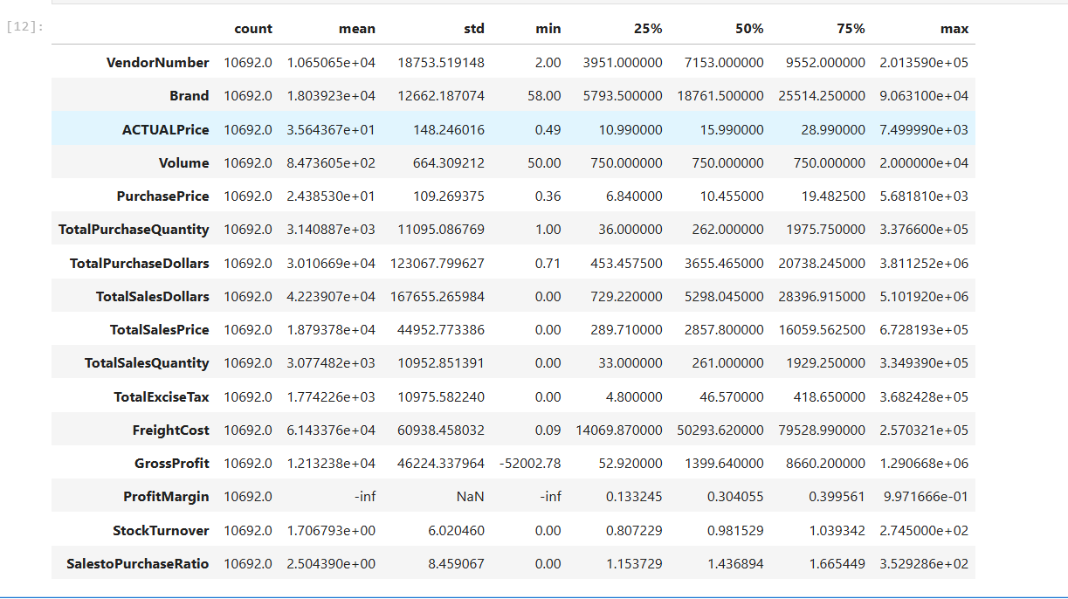

The dataset comprises **10,692 records**, representing vendor and product-level performance. The average **actual price** across items is approximately **₹35.64**, with considerable variability (std: ₹148.25), indicating a wide pricing range. The **average sales volume** is around **847 units**, while the **average gross profit** per record stands at approximately **₹12,133**, reflecting substantial revenue generation potential. Notably, some entries show **zero or negative margins**, which require further investigation into pricing, returns, or data inconsistencies.

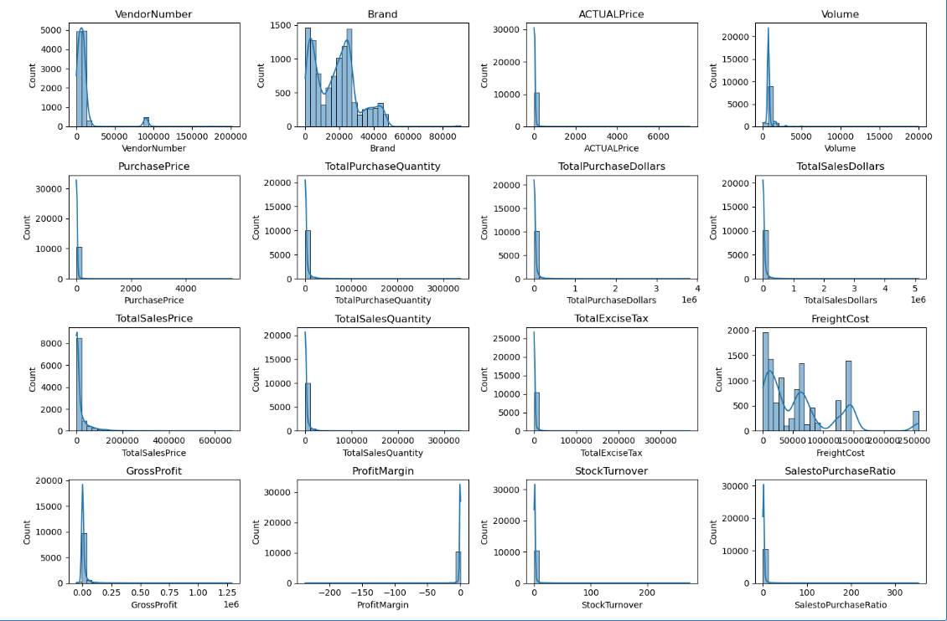

**Key Data Observations**

**🔻 Negative & Zero Values**

* **Gross Profit:**  
  A minimum value of **-52,002.78** was observed, indicating significant potential losses. This may result from high purchase costs or aggressive discounting, where items are sold below cost.
* **Profit Margin:**  
  The data includes instances with a profit margin of **negative infinity (-∞)**, implying that some products generated no revenue or were sold below their purchase price, leading to severe negative margins.
* **Total Sales Quantity & Sales Dollars:**  
  Several records show **zero sales** despite purchase activity. These could indicate **obsolete or slow-moving inventory**, contributing to holding costs and inefficiencies in inventory management.

**Outliers Detected by High Standard Deviations**

* **Purchase & Actual Prices:**

The dataset includes **extreme values** such as **5,681.81** and **7,499.99**, which are significantly higher than the mean purchase and actual prices (**24.39** and **35.64**, respectively). These may correspond to **premium products** or **pricing anomalies** and should be reviewed for consistency and relevance to the product mix.

* **Freight Cost Variability**

Freight costs in the dataset range from 0.09 to 257,032.07, highlighting significant variability. This fluctuation may be attributed to bulk or irregular shipments, regional shipping inefficiencies, and product-specific logistics challenges. Such inconsistency in freight expenses can directly affect profit margins and should be closely monitored to identify opportunities for optimizing supply chain operations and cost management.

* **Stock Turnover Insight**

**Stock turnover ranges from 0 to 274.5, indicating significant variation in product movement. Low values suggest stagnant or excess inventory, while high values reflect faster sales, often fulfilled from existing stock. A turnover rate above 1 signals reliance on older inventory, highlighting the need for optimized replenishment strategies.**

**Data Filtering**

**To ensure reliable insights, the following data points were excluded:**

* **Gross Profit ≤ 0 – Removes loss-generating transactions.**
* **Profit Margin ≤ 0 – Focuses analysis on profitable items.**
* **Total Sales Quantity = 0 – Excludes unsold inventory.**

**CORRELATION INSIGHTS**

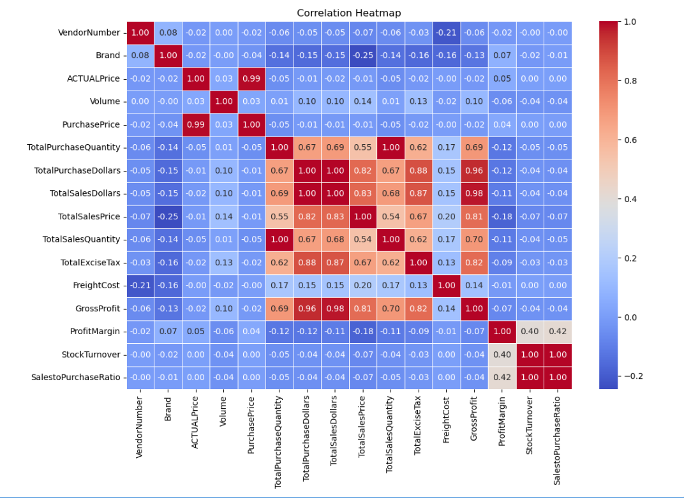

**Purchase Price vs. Sales & Profit: Shows weak negative correlations (-0.012 and -0.016), indicating that changes in purchase price have minimal impact on total sales revenue or gross profit.**

**Total Purchase Quantity vs. Total Sales Quantity: Displays a very strong positive correlation (0.999), suggesting highly efficient inventory turnover.**

**Profit Margin vs. Total Sales Price: Exhibits a moderate negative correlation (-0.179), implying that higher sales prices may reduce profit margins, potentially due to market competition.**

**Stock Turnover vs. Gross Profit & Profit Margin: Reveals weak negative correlations**

**038 and -0.055), indicating that faster stock turnover doesn’t necessarily result in higher profitability.**

**RESEARCH QUESTION & KEY FINDINGS**

**1.Brands for promotional or Pricing Adjustments**

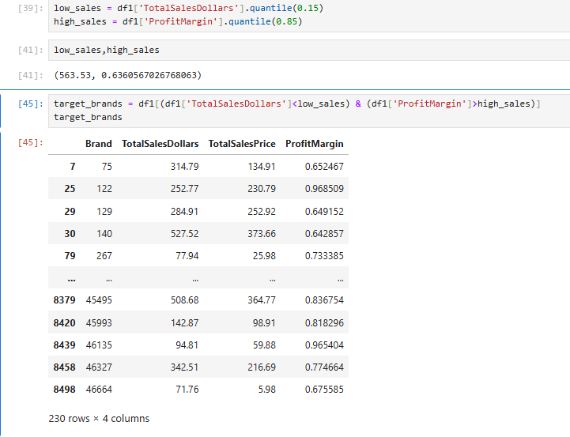

203 brands show low sales but high profit margins, suggesting potential for growth through targeted marketing or pricing strategies

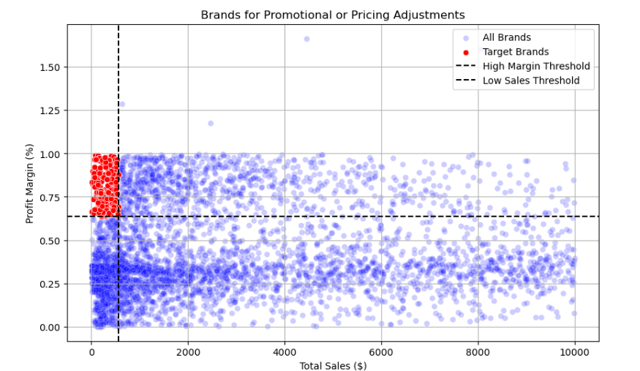

**2. Top Vendors by Sales & Purchase Contribution**  
The top 6 vendors account for nearly half (49.98%) of total purchases, with Diageo North America Inc. leading at 16.3%, followed by Martignetti Companies (8.3%) and Pernod Ricard USA (7.76%). The remaining 50.02% is split among various smaller vendors. This heavy reliance on a few suppliers highlights potential supply chain vulnerabilities and underscores the importance of vendor diversification.

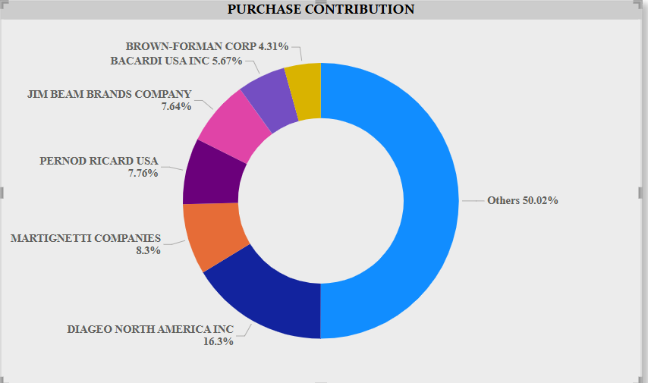

**3. Impact of Bulk Purchasing on Cost Savings**  
Large quantity purchases result in significantly lower unit costs—up to 72% less compared to small orders. This cost efficiency supports bulk pricing strategies, which promote larger order volumes, boosting overall sales while preserving profitability.

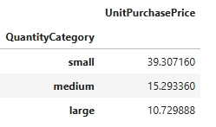

**4. Identifying Vendors with Low Inventory Turnover**  
With $2.71M tied up in unsold stock, slow-moving inventory leads to higher storage costs, reduced cash flow, and decreased profitability. Recognizing vendors with low turnover helps improve stock control and reduces financial pressure through more efficient inventory management

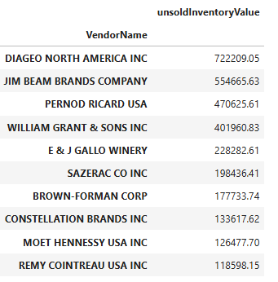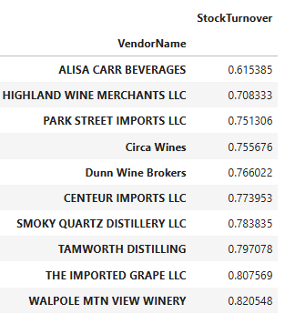

**5. Profit Margin Comparison: High- vs. Low-Performing Vendors**

* **Top Vendors’ Profit Margin (95% Confidence Interval)**: (30.74%, 31.61%) **Mean**: 31.17%
* **Low Vendors’ Profit Margin (95% Confidence Interval)**: (40.48%, 42.62%) **Mean**: 41.55%

**Interpretation**:  
Low-performing vendors have higher profit margins but face challenges in selling large volumes. This may indicate issues with pricing strategy or limited market reach.

**Actionable Insight**:

* **Top-performing vendors** should focus on increasing profitability by:
  + Adjusting pricing strategies
  + Cutting down operational expenses
  + Offering bundled promotions to attract more customers
* **Low-performing vendors** should focus on strengthening marketing efforts, refining pricing strategies, and expanding their distribution networks.

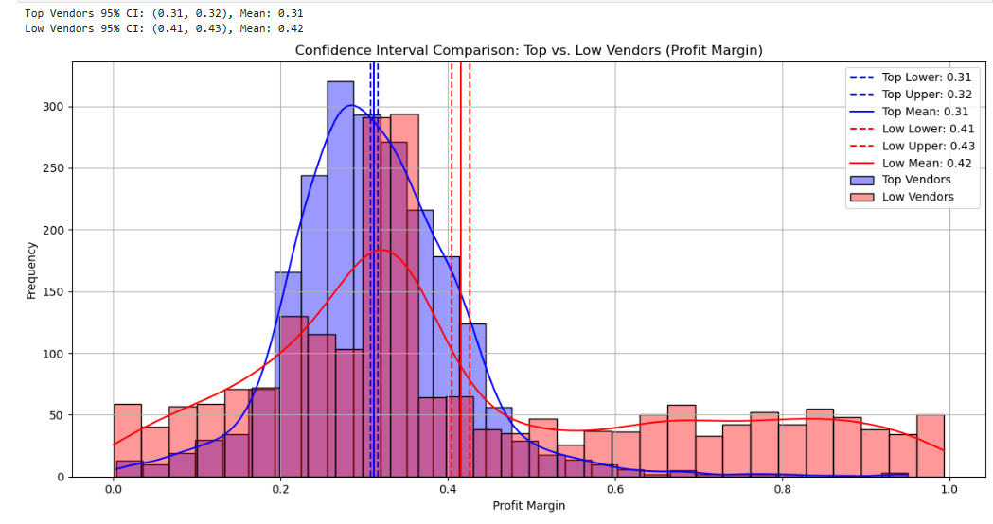

**FINAL RECOMMENDATION**

**Re-evaluate pricing for low-sales, high-margin brands to boost sales volume without sacrificing profitability.**

**Broaden vendor relationships to minimize reliance on a limited number of suppliers and reduce supply chain vulnerabilities.**

**Utilize bulk purchasing power to secure competitive pricing and improve inventory management efficiency.**

**Manage slow-moving inventory by modifying order volumes, initiating clearance promotions, or updating storage approaches.**

**Strengthen marketing and distribution efforts for underperforming vendors to boost sales volumes while maintaining profit margins.**

**By adopting these strategies, the company can achieve sustainable profitability, reduce risks, and improve overall operational efficiency.**